Table of Contents

Google Sites at School
Links to Google Sites
Browse Google Sites at your school
Search Google Sites at your school
Google Sites as a wiki
Overview
Google sites at your school vs. Google Sites with Gmail
Quick principles of well designed and usable sites
Audience
Design
Content
Navigation
Dancing bears

Google Sites at School

Links to Google Sites
You can access Google Sites from any of your school Google Apps product pages.
- In the top left corner of any product main page, you will see a list of links.
- Click Sites.
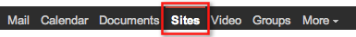
In addition to the links at the top left of any Google Apps page, you can also access Google Sites through a custom URL for your school:
- Type http://sites.google.com/a/yourschool.org into your browser address bar. Please replace yourschool.org with your school Apps domain name

Browse Google Sites at your school
When you see your school's Google Sites page, you will see a list of your sites on your school's domain. These are sites that you own or have been given access to.

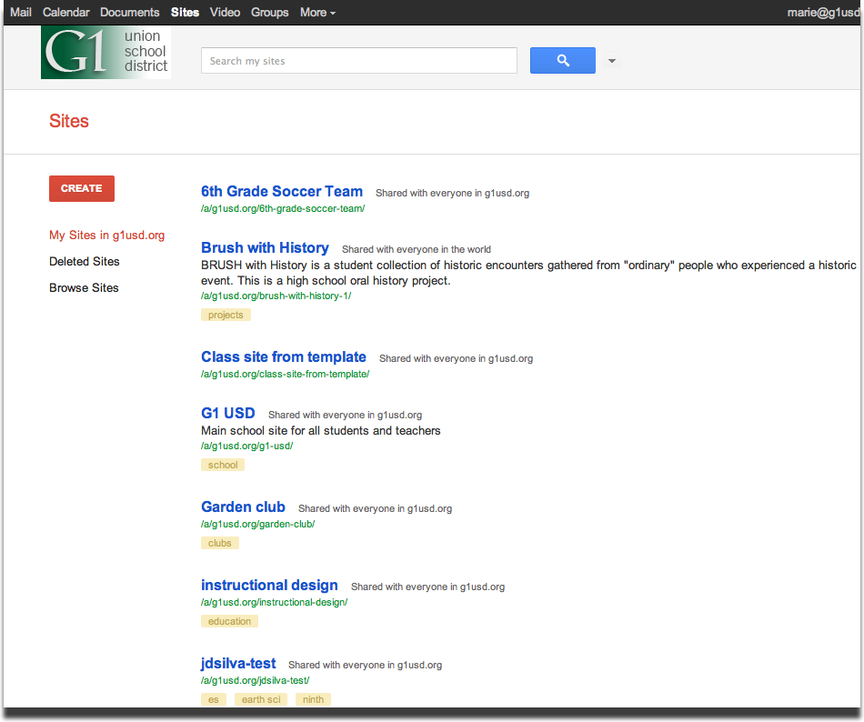

Please note: These are sites that are created at yourschool.org on the domain sites.google.com/a/yourschool.org.

This list will NOT have sites that you created using a Gmail or non-Google Apps account. Those sites are created under sites.google.com/site/ and will not appear in your school Google Apps list.

You can also browse all the sites created on your school's domain by scrolling to the bottom of your list and clicking Browse sites within yourschool.org »

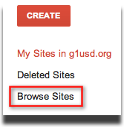
From here, you will see a list of categories. Categories are added to sites by site owners. You can click on a category to view sites that have been tagged with that category.
Categories allow you to group related sites and make them accessible together within the popular categories list. Categories are deemed popular when they contain more than five sites. This setting does not affect search results.

At this point, you will see a list of sites under the heading Sites categorized as ...

Each line will have a site name (linked to the site homepage), the categories for the site (if available), and a site description (if available).

You can click on other categories on the left size to view more lists of sites.

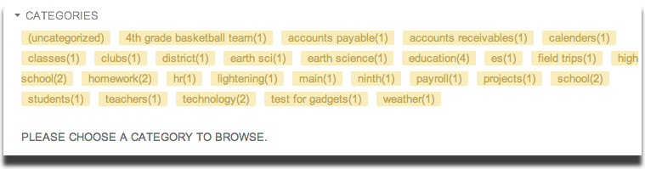

Search Google Sites at your school
You can use Google search to find content within your sites or within all the sites at your school.

To search for information on your sites:
- Go to Google Sites for your school (either clicking the Sites link in the top left of any Apps page or going to http://sites.google.com/a/yourschool.org).
- Click inside the search box in the top right corner of your sites list.
- Enter the terms for your search.
- Choose from the drop down menu whether you want to search just your sites (listed on that page) or all the sites available at your school.
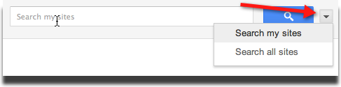
- Click Search my sites or Search all sites.

The search results will highlight sites, pages, images, or files that relate to your search terms. Depending on which selection you chose, it will return results either from your sites or from all the sites in your school domain.

Google Sites as a wiki

Overview
Google Sites is an online application that makes creating a class, school, or project web site as easy as editing a document. With Google Sites, people can quickly gather a variety of information in one place -- including videos, calendars, presentations, attachments, and text -- and easily share it for viewing or editing with a small group, their class, the entire school, or sometimes the world. You always control who has access to your site.

Think of building a site in Google Sites as creating a collaborative wiki. A "wiki" is a website that can be easily edited by multiple authors. You can allow others contribute to the site, track the changes made to your site, and add rich media – no html programming required.

Here's what you can do with Google Sites:
- Customize your site.
- Create sub-pages to keep your content organized.
- Add navigation menus
- Choose page types: webpage, announcements, file cabinet, lists, dashboards, start pages.
- Have a central location for your web content and offline files.
- Keep your site as private or public as you'd like.
- Search across your Google Sites content with Google search technology.

Google sites at your school vs. Google Sites with Gmail
Here are some key differences between using your school domain Google Sites with your school Apps account Google Sites (not on your school domain, with a Gmail account)

Feature | Google Sites on your school domain | Google Sites
Sites Quota | n/a - tracked at school domain level | 100 MB/site
Quota per domain | 100Gb for all sites at the school domain | n/a, not using custom domain
Max attachment size | 20 Mb | 20 Mb
Sites per domain | unlimited | n/a
Pages per site | unlimited | unlimited
Site categories | unlimited - group related sites together | n/a
Who can create sites | Only those with a Google Apps account with school domain | anyone

Quick principles of well designed and usable sites

Audience
Know your audience
When you start creating your website, you should always keep in mind the intended audience. This can change how you should present the information, what navigation is important etc.

Here are a few things to think about:
- Who are they? Are they students, teachers, parents, or a mix of all?
- What are they looking for? What information is most important to them - you will want to highlight this information in the design of your site.
- What's their technical ability? Depending on how familiar they are with technology, you may need to provide more or less instructions.
- Advanced or new users? This will help determine the depth of instruction you should include on your site.
- Are they web saavy users or are they new to the Internet?

Design
Design - choose a design that flatters, not distracts from your content

Google Sites has several layout and design templates to choose from. One of the easiest ways to create a site is to use a pre-designed templates that can set you up with site organization and ideas for content.

In addition to these pre-designed templates, there are also some basic site templates available that let you choose a color, font, and graphical scheme for your site.

Here are a few things to think about:
- Choose appropriate colors, fonts and images for your Site's theme. Try to avoid 'clashing' colors, or stick to the default theme colors (the colors were made to match the color scheme)
- Use whitespace to help separate sections of your site. Whitespace works in many ways - it gives your user 'space' to process the webpage, can be used as an 'invisible' divider or information, and prevents your site from looking cluttered and confusing.
- Use images that help explain the material, not distract from it. With all the graphic and image sources out there, it can be tempting to try and add images all over your site. Be aware that images can distract from the page and add them judiciously (do they add value to the content? does it help the user find what they are looking for?)

Example: https://sites.google.com/site/teacher25/projekte-proyectos/artistas/gabriele-muenter
This is a site to showcase student artwork, the background image use of colors matches the theme of the Site.

Content
Keep it simple
When someone visits your website, they should be able to quickly browse through the pages and find the information they are looking for. One way to achieve this is with headings. Come up with descriptive and concise headings to categorize your content.

Here are a few things to think about:
- Expose the most important information "above the fold." The fold is the point when a user has to scroll down to see the rest of the webpage. If your best and most relevant content is 'hidden' down the page and requires scrolling, you run a risk of a user not seeing it. If at all possible, try to keep all your information above the fold.
- Use headings easy to see and make sense. Headings should stand out - you can bold the text, make it a size or two larger. These will be used by the user while scanning the page. The headings should also be relevant to the associated content.
- Short and sweet paragraphs. A webpage is not the place to be reading long blocks of content - text on your page should inform quickly and easily. Keep paragraphs descriptive but concise.
- 15 second rule: if someone has only 15 seconds to review a page, can your expected user (teacher, student, parent, other) find the information they need quickly?

Example: https://sites.google.com/site/teacher8/Home
This site is well organized, the content is well structured and makes a good use of headings.

Example: https://sites.google.com/site/teacher22
This site is also well organized and structured.

Navigation
Don't make me think!
When someone visits your site for the first time, they should be able to tell what's within your site just by looking at the 5-7 navigation links included in your site.

Here are a few things to think about:
- Try to use no more than 5-7 links in your main navigation. More than that can be overwhelming. Instead of having a long laundry list of links, use sub-pages (pages that are linked within the main navigation links) to display additional information or links. Google Sites has an option to include subpage dropdown in your main navigation.
- Use 'breadcrumb' links. 'Breadcrumbs' show a list of the link hierarchy or navigation so that a user knows where they've been and where they are going. Google Sites automatically includes a breadcrumb on your pages. Sites has breadcrumbs at the top. to get out of the subpage, can go back to the main, 'top level' page

Example: https://sites.google.com/site/teacher18/emoh
This site has a good navigational structure. There are only 6 links in the main navigation. Sub-pages are used in this section so the user can see these are subpages of the "how to" section. https://sites.google.com/site/teacher18/how-to-1

Example: https://sites.google.com/site/teacher34/
Here is a site that does not have more than seven elements in the navigation but the navigation is broken into separate sections that makes the site easier to browse.

Dancing bears
Animation can be very distracting.
When you start designing a site, there are many options to add rich media. Take care when adding things like animated gifs, elaborate colors and fonts to your site. Google Sites does allow creativity to do this, but it can be very distracting.

Here are a few things to think about:
- Avoid animation. If necessary, have only one per page. An animated image can take the attention away from your web content. If the animation is necessary to the information in your website, then keep it to a minimum - 1 at most.
- Avoid noises and music. Opening a website and suddenly hearing music or noises can surprise users. Use music and noises only if necessary and relevant to your content - and even then, try and use a player that can allow the user to control the sound instead of autoplaying.

